Jeio Prosecco Rosé
Prosecco Rosé D.O.C.

In the new Jeio Doc Rosé the blend of Glera and Pinot Nero creates a wine that is able to transmit the beauty of the nature and places in which it has its origins, synthesizing the style of the Valdobbiadene located company. The hamlet in which winemaking is truly privileged for its unique position between Cortina d’Ampezzo, “Queen of the Dolomites”, and Venice, with its millennial appeal infused with culture, artistic splendour and history.Agronomic attention is at its highest amongst the rows of vines cultivated with the “double curtain” and “sylvoz” training systems, where every decision is taken in full respect for the environment, the ecosystem and biodiversity. The philosophy followed in the vineyards is not dissimilar to that applied in the winery where we are constantly seeking to obtain the maximum quality standards and to get the best out of the raw materials which, exalted during the production processes, bring to the forefront all that the season and land has endowed the bunches of grapes with.

GRAPE VARIETY
85% Glera,15% Pinot Nero. Locally sourced

COLOUR
The Tiepolo -a very famous Venetian artist- Pink
in the glass offers a delicate and brilliant nuances,
with a very fineperlage

BOUQUET
Floral, sweetness of rose and lily of the valley, with a fresh citrus fragrance.

FLAVOUR
Soft and balanced, clean cut, distinct and elegantly penetrating

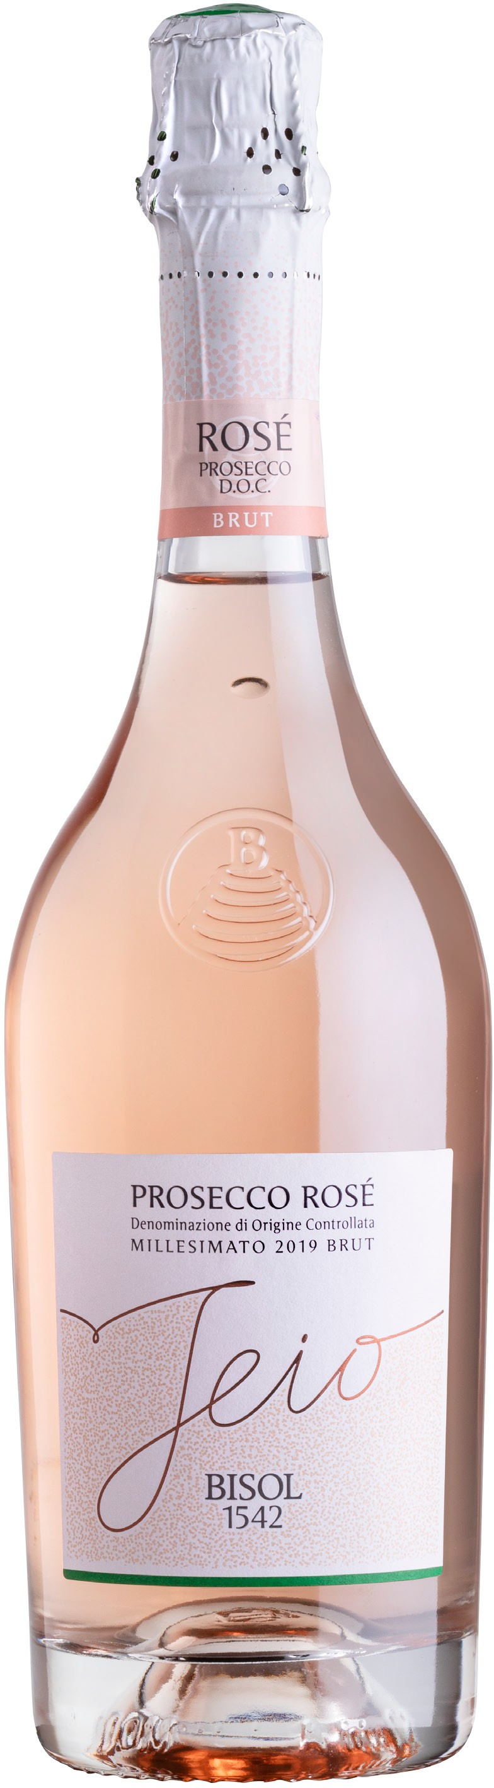
CANOPY MANAGEMENT:

GRAPE HARVESTING PERIOD:

ALCOLHO CONTENT: SUGAR CONTENT: OVERALL ACIDITY:
Double curtain, Sylvoz system

Month of September.
The Follina pinot nero harvest precedes the glera harvest by about a week

11% vol.

6,5 grams per litre 5,5 grams per litre

